Neighborhood Components Analysis (NCA, NeighborhoodComponentsAnalysis) is a distance metric learning algorithm that aims to improve the accuracy of nearest neighbors classification compared to the standard Euclidean distance. The algorithm directly maximizes a stochastic variant of the leave-one-out k-nearest neighbors (KNN) score on the training set. It can also learn a low-dimensional linear projection of data that can be used for data visualization and fast classification.

**[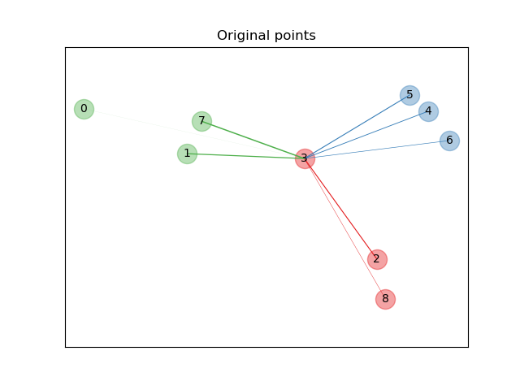](https://scikit-learn.org/stable/auto_examples/neighbors/plot_nca_illustration.html) [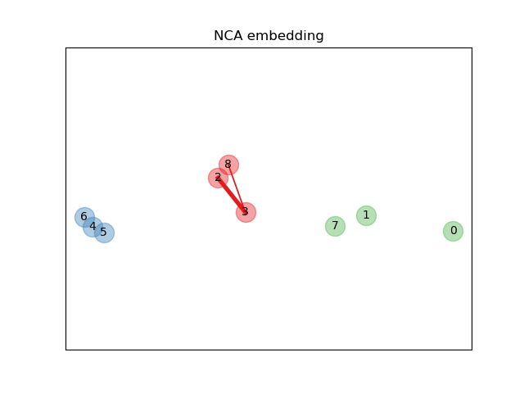](https://scikit-learn.org/stable/auto_examples/neighbors/plot_nca_illustration.html)**

In the above illustrating figure, we consider some points from a randomly generated dataset. We focus on the stochastic KNN classification of point no. 3. The thickness of a link between sample 3 and another point is proportional to their distance, and can be seen as the relative weight (or probability) that a stochastic nearest neighbor prediction rule would assign to this point. In the original space, sample 3 has many stochastic neighbors from various classes, so the right class is not very likely. However, in the projected space learned by NCA, the only stochastic neighbors with non-negligible weight are from the same class as sample 3, guaranteeing that the latter will be well classified.